EXPERIMENT NO.2

- VHDL CODE:

-- Experiment No 2.4-bit ALU for add, substract, AND, NAND, OR, XOR, NOR and XNOR.
-- Name : Ritesh Machindra Todmal
-- Roll No. : 404C001
-- Teacher Name: Dr.D.G.Ganage
-- Batch : C1

library IEEE;
use IEEE.STD_LOGIC_1164.ALL; use IEEE.STD_LOGIC_ARITH.ALL;
use IEEE.STD_LOGIC_UNSIGNED.ALL;

entity ALU_4bit is
Port ( a : in STD_LOGIC_VECTOR (3 downto 0);
b : in STD_LOGIC_VECTOR (3 downto 0); sel : in STD_LOGIC_VECTOR (2 downto 0); y : out STD_LOGIC_VECTOR (3 downto 0));
end ALU_4bit;
architecture Behavioral of ALU_4bit is begin
process (a, b, sel) begin
case sel is
when "000" => y <= a + b; when "001" => y <= a - b; when "010" => y <= b - a; when "011" => y <= a and b; when "100" => y <= a or b; when "101" => y <= a nand b;
when "110" => y <= a xor b; when "111" => y <= a nor b; when others => null;
end case; end proces;
end Behavioral;

- VHDL TESTBENCH:

-- Experiment No 2. - 4-bit ALU for add, substract, AND, NAND, OR, XOR, NOR and XNOR.
-- Name : Ritesh Machindra Todmal
-- Roll No. : 404C001
-- Teacher Name: Dr.D.G.Ganage
-- Batch : C1

LIBRARY ieee;
USE ieee.std_logic_1164.ALL;

ENTITY ALU_TB IS END ALU_TB;

ARCHITECTURE behavior OF ALU_TB IS
-- Component Declaration for the Unit Under Test (UUT) COMPONENT ALU_4bit
PORT(
- : IN std_logic_vector(3 downto 0);
- : IN std_logic_vector(3 downto 0); sel : IN std_logic_vector(2 downto 0);
y : OUT std_logic_vector(3 downto 0)
);
END COMPONENT;

--Inputs
signal a : std_logic_vector(3 downto 0) := (others => '0'); signal b : std_logic_vector(3 downto 0) := (others => '0'); signal sel : std_logic_vector(2 downto 0) := (others => '0');

--Outputs
signal y : std_logic_vector(3 downto 0);
-- No clocks detected in port list. Replace <clock> below with
-- appropriate port name BEGIN
-- Instantiate the Unit Under Test (UUT) uut: ALU_4bit PORT MAP (
a => a,
b => b,
sel => sel, y => y
);

-- Stimulus process stim_proc: process begin
a <= "1010";
b <= "0101";
sel <= "000";
wait for 10 ns; sel <= "001";
wait for 10 ns; sel <= "010";
wait for 10 ns;
sel <= "011";
wait for 10 ns; sel <= "100";
wait for 10 ns; sel <= "101";
wait for 10 ns; sel <= "110";
wait for 10 ns; sel <= "111";
wait for 10 ns;

end process; END;

- SIMULATION RESULT

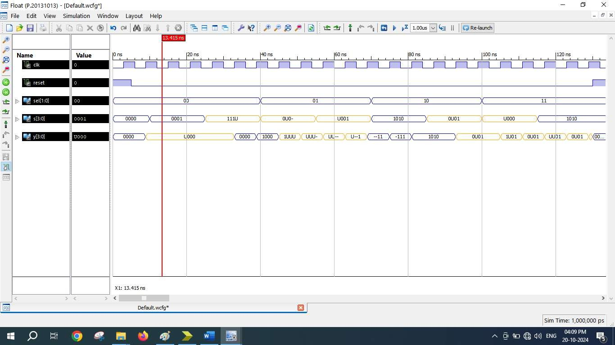

- SCHEMATICS (RTL Technology)
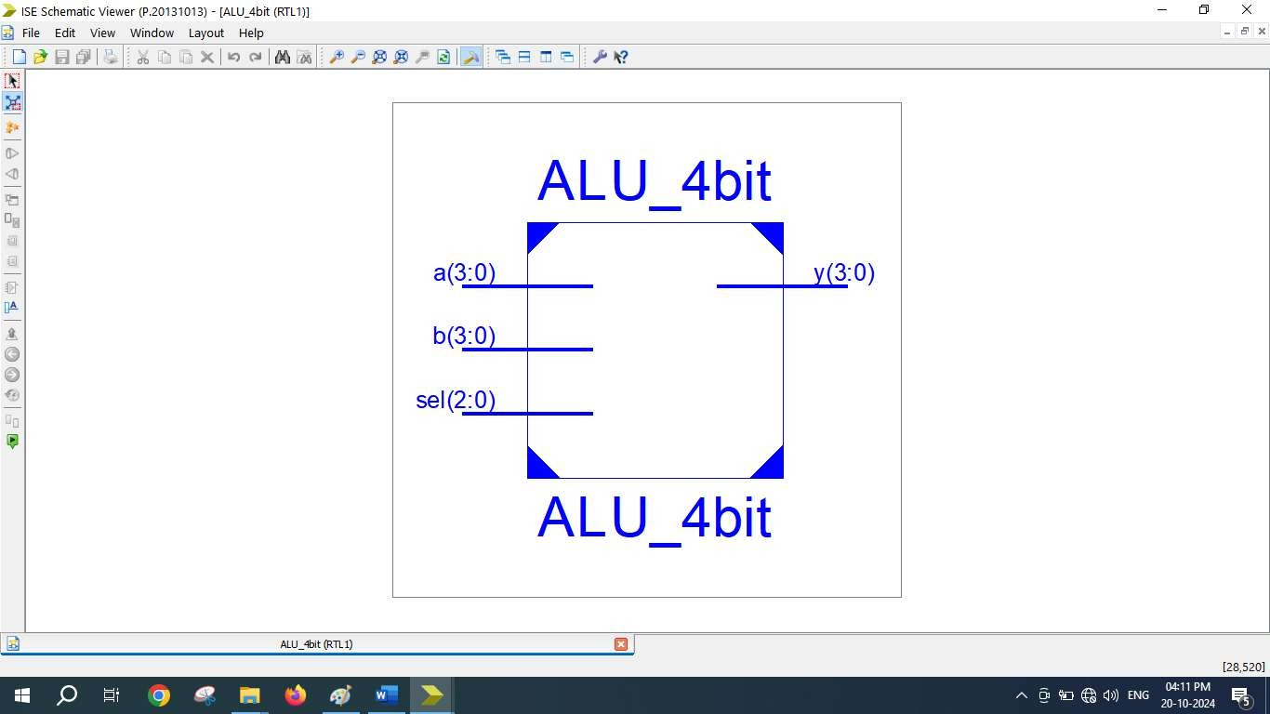

=========================================================================
* Final Report *
=========================================================================
Final Results
RTL Top Level Output File Name : ALU_4bit.ngr Top Level Output File Name : ALU_4bit
Output Format : NGC
Optimization Goal : Speed
Keep Hierarchy : No

Design Statistics
# IOs : 15

Cell Usage :
# BELS : 30
# INV : 1
# LUT2 : 2
# LUT3 : 2
# LUT4 : 18
# MUXF5 : 7
# IO Buffers : 15
# IBUF : 11
# OBUF : 4
=========================================================================
Device utilization summary:

Selected Device : 3s250epq208-5

Number | of | Slices: | 13 | out | of | 2448 | 0%
Number | of | 4 input LUTs: | 23 | out | of | 4896 | 0%
Number | of | IOs: | 15
Number | of | bonded IOBs: | 15 | out | of | 158 | 9%

Partition Resource Summary:

No Partitions were found in this design.

=========================================================================

